1. **a Git repository**

<https://github.com/olowofelayinka/image-filter-starter-code>

1. **a screenshot of the elastic beanstalk application dashboard after deployement**

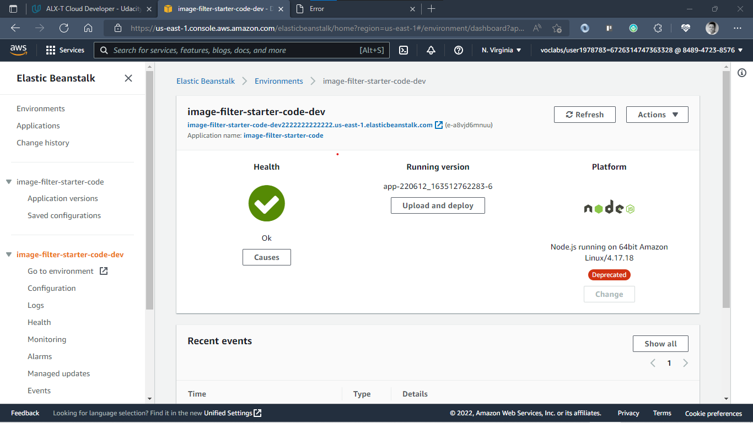

1. **a link to the endpoint URL for a running elastic beanstalk deployment either in the Project README or in the project submission notes.**

<http://image-filter-starter-code-dev2222222222222.us-east-1.elasticbeanstalk.com/>